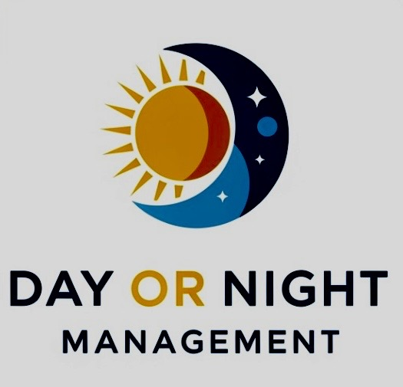

Resident Application and Housing Agreement

PLEASE PRINT CLEARLY

Name (Last, First, Middle Initial)

_____________________________________________

DOB ______________________

SSN _______________________

Last Address _______________________________________

Cell #______________________

Email______________________
Marital Status/# of dependents_________________________

Auto Make/Model/License Plate# _______________________

Vehicles must have valid and current insurance to be on Day or Night Management Property.

Company: _____________________________

Policy # _______________________________

Driver's License State/#_____________________________

Emergency Contact (Name, Relation, phone, email)

__________________________________

Probation or Case Worker Name and number:

_______________________________________

Do you smoke? (Y or N) Allergies? (Y or N)

type?___________________________________

SOBRIETY INFORMATION:

Last Treatment/Sober House ____________________________

Current Clean Date ___/____/_____ Longest period of clean time _____

Do you consider yourself an addict? Yes or NO (please circle)

Do you consider yourself an alcoholic? Yes or No (please circle)

Drugs you have used: _________________________________

Sponsor’s Name and contact # __________________________

List all current medications and what they are for:

__________________________________________________________

ACKNOWLEDGEMENT & AGREEMENT

THIS IS A LEGAL AND BINDING DOCUMENT. PLEASE READ IT VERY CAREFULLY BEOFRE SIGNING.

___ I have carefully read and truthfully answered all applicable questions above, I agree to provide updated information if any of my answers change while I am a resident at Day or Night Management.

___ I realize that Day or Night Management LLC has an established in compliance with the conditions of *2036* of the Federal Anti-Drug Abuse Act of 1998, P. L. 100-690 (as amended), which provides pertinent part that a sober house:

*Prohibits all residents from using alcohol or illegal mind-altering substances on the property

*Owners can discharge any resident who violates such prohibition

___I have read and fully understand the Rules and Expectations of Day or Night Management and will request a copy of you want one.

___I am currently of sound mind and not under the influence of any drugs or alcohol.

___I agree that I am a participant in the program and not a tenant. I agree that I am not protected by, nor will I invoke any protections of local landlord tenant laws. If it is found that local landlord tenant laws apply, I hereby waive any rights that I may or may not have under the same.

___I agree that I will participate in the programs of Day or Night Management LLC and will abide of all rules and expectations.
____I specifically agree that if I violate any of the rules or expectations of Day or Night Management I can be discharged from Day or Night Management and forfeit any client. I agree that final determination of any disciplinary action will be made by Night or Day Management LLC and may not be appealed or retaliated.

_____I hereby release and hold harmless Day or Night Management LLC and all its managers from any lawsuits of whatever nature that may be brought to me, my heirs and/or my representatives in perpetuity.

_____in accordance with state and federal law and the principles of a 12-step program Day or Night Management LLC does not discriminate based on race, color, religion, sex, national origin, disability, sexual orientation, HIV or Hepatitis status. By my initials, I agree with principles and acknowledge that I may be living in the same house as a member of a member of a protected group.

_____I agree that I am ultimately responsible for my own valuables and other personal property during and after my residency at Day or Night Management LLC.

______I agree if I am terminated from my residency for violating a Day or Night Management LLC Rules and Expectations as set forth in this agreement, deposit and any paid fees/rent will not be refunded.

______I agree if I stop or get discharged from groups at my Outpatient Treatment program; I will automatically be discharged and asked to leave from Day or Night Management LLC.

Applicant Signature and Date

_________________________ ________________

Witness Signature and Date

_________________________ _________________

